# Use case 00: An actor who is not authenticated cannot be able to list.

Description

An unauthenticated actor wishes to list folders.

Access

https://www.acme.com/folder/actor/list.do

Tests

|  |  |
| --- | --- |
| **Test 001** | |
| **Description** | With the language set to “English”, the testers must access to the given URL. |
| **Expected** | The system must show the logging page. |
| **Outcome** |  |
| **Notes** |  |

|  |  |
| --- | --- |
| **Test 001** | |
| **Description** | With the language set to “Spanish”, the testers must access to the given URL. |
| **Expected** | The system must show the logging page. |
| **Outcome** |  |
| **Notes** |  |

Access

https://www.acme.com/folder/actor/list.do?parentId=239

Tests

|  |  |
| --- | --- |
| **Test 001** | |
| **Description** | With the language set to “English”, the testers must access to the given URL. |
| **Expected** | The system must show the logging page. |
| **Outcome** |  |
| **Notes** |  |

|  |  |
| --- | --- |
| **Test 001** | |
| **Description** | With the language set to “Spanish”, the testers must access to the given URL. |
| **Expected** | The system must show the logging page. |
| **Outcome** |  |
| **Notes** |  |

# Use case 00: An actor who is authenticated must be able to manage his or her folders, except for the system folders.

Description

An authenticated actor wishes to list, edit, move or delete his or her folders.

Access

(Logged as “user1”, please refer to the test related to logging as user for more information)

Main menu > Folders and Messaging.

Tests

|  |  |
| --- | --- |
| **Test 001** | |
| **Description** | With the language set to “English”, the testers access. |
| **Expected** | The system must show the list of the folders. It must contain 6 folders. |
| **Outcome** |  |
| **Notes** |  |

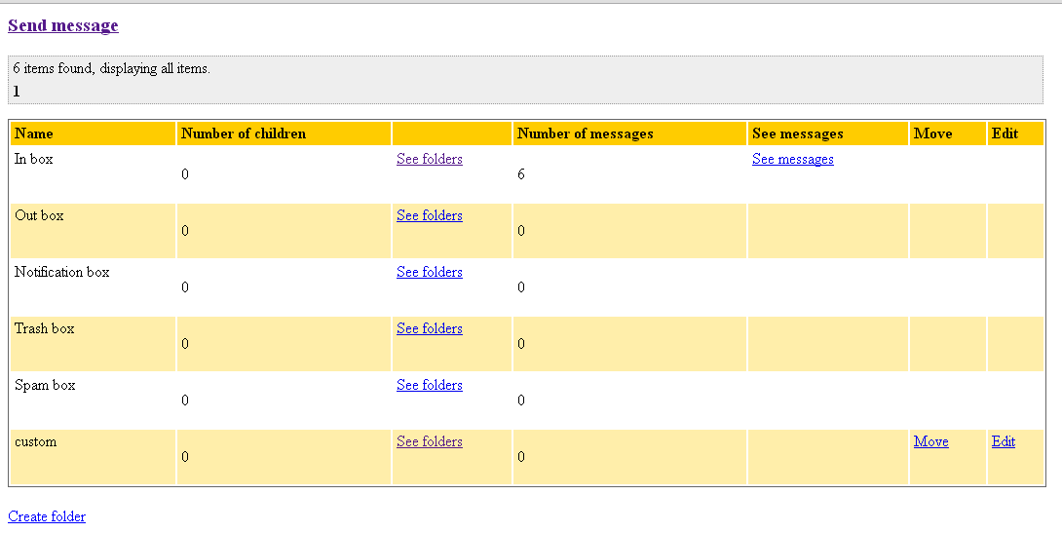

|  |  |
| --- | --- |
| **Test 001** | |
| **Description** | With the language set to “Spanish”, the testers access. |
| **Expected** | The system must show the list of the folders. It must contain 6 folders. |
| **Outcome** |  |
| **Notes** |  |

Access

(Logged as “user2”, please refer to the test related to logging as user for more information)

Main menu > Folders and Messaging.

Tests

|  |  |
| --- | --- |
| **Test 001** | |
| **Description** | With the language set to “English”, the testers must list the ‘In box’ children folders. |
| **Expected** | The system must show the list of the folders. It must contain one folder. |
| **Outcome** |  |
| **Notes** |  |

|  |  |
| --- | --- |
| **Test 001** | |
| **Description** | With the language set to “English”, the testers must list the ‘In box’ children folders. |
| **Expected** | The system must show the list of the folders. It must contain one folder. |
| **Outcome** |  |
| **Notes** |  |

Access

(Logged as “user1”, please refer to the test related to logging as user for more information)

Main menu > Folders and Messaging.

Tests

|  |  |
| --- | --- |
| **Test 001** | |
| **Description** | With the language set to “English”, the testers must create a folder. The name will be ‘In box’. |
| **Expected** | The system must not let them create it. |
| **Outcome** |  |
| **Notes** |  |

|  |  |
| --- | --- |
| **Test 001** | |
| **Description** | With the language set to “Spanish”, the testers must create a folder. The name will be ‘In box’. |
| **Expected** | The system must not let them create it. |
| **Outcome** |  |
| **Notes** |  |

|  |  |
| --- | --- |
| **Test 001** | |
| **Description** | With the language set to “English”, the testers must create a folder. The name will be in blank. |
| **Expected** | The system must not let them create it. |
| **Outcome** |  |
| **Notes** |  |

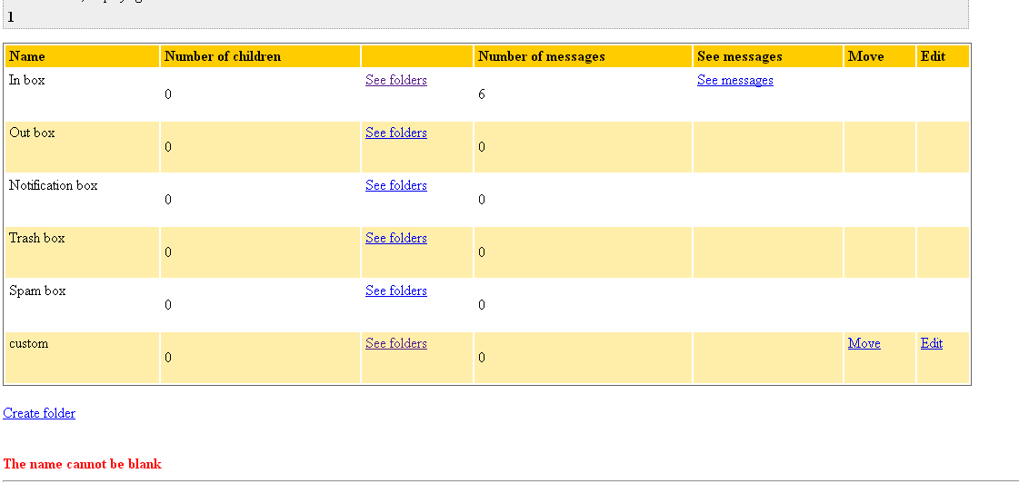

|  |  |
| --- | --- |
| **Test 001** | |
| **Description** | With the language set to “Spanish”, the testers must create a folder. The name will be in blank. |
| **Expected** | The system must not let them create it. |
| **Outcome** |  |
| **Notes** |  |

|  |  |
| --- | --- |
| **Test 001** | |
| **Description** | With the language set to “English”, the testers must create a folder. The name will be ‘newFolder’. |
| **Expected** | The system must let them create it. And it appears in the list of folders. |
| **Outcome** |  |
| **Notes** |  |

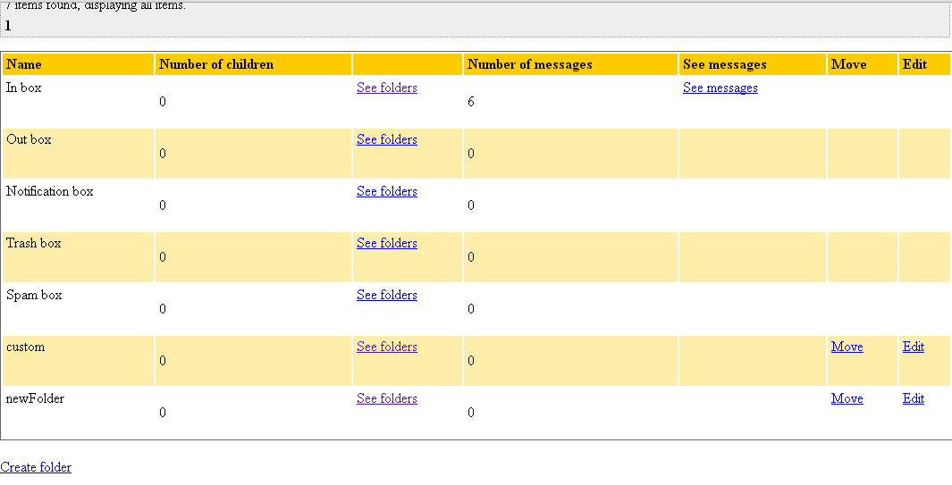

|  |  |
| --- | --- |
| **Test 001** | |
| **Description** | With the language set to “Spanish”, the testers must create a folder. The name will be ‘nuevaCarpeta’. |
| **Expected** | The system must let them create it. And it appears in the list of folders. |
| **Outcome** |  |
| **Notes** |  |

|  |  |
| --- | --- |
| **Test 001** | |
| **Description** | With the language set to “English”, the testers must create a folder. The name will be ‘newFolder’. |
| **Expected** | The system must not let them create it. |
| **Outcome** |  |
| **Notes** |  |

|  |  |
| --- | --- |
| **Test 001** | |
| **Description** | With the language set to “Spanish”, the testers must create a folder. The name will be ‘nuevaCarpeta’. |
| **Expected** | The system must not let them create it. |
| **Outcome** |  |
| **Notes** |  |

|  |  |
| --- | --- |
| **Test 001** | |
| **Description** | With the language set to “English”, the testers must access to the list of folders which are children of ‘In box’. Then, they will create a new folder. The name will be ‘Out box’. |
| **Expected** | The system must not let them create it. |
| **Outcome** |  |
| **Notes** |  |

|  |  |
| --- | --- |
| **Test 001** | |
| **Description** | With the language set to “Spanish”, the testers must access to the list of folders which are children of ‘In box’. Then, they will create a new folder. The name will be ‘Out box’. |
| **Expected** | The system must not let them create it. |
| **Outcome** |  |
| **Notes** |  |

|  |  |
| --- | --- |
| **Test 001** | |
| **Description** | With the language set to “English”, the testers must access to the list of folders which are children of ‘In box’. Then, they will create a new folder. The name will be ‘newChildrenFolder’. |
| **Expected** | The system must let them create it. And it appears in the list of folders. |
| **Outcome** |  |
| **Notes** |  |

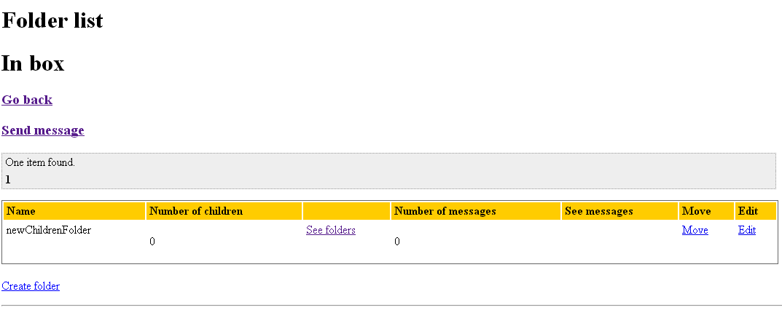

|  |  |
| --- | --- |
| **Test 001** | |
| **Description** | With the language set to “Spanish”, the testers must access to the list of folders which are children of ‘In box’. Then, they will create a new folder. The name will be ‘nuevaCarpetaHija. |
| **Expected** | The system must let them create it. And it appears in the list of folders. |
| **Outcome** |  |
| **Notes** |  |

|  |  |
| --- | --- |
| **Test 001** | |
| **Description** | With the language set to “English”, the testers must rename the folder ‘newFolder’ to ‘renamedFolder’. |
| **Expected** | The system must let them rename it. It appears in the list of folders with the new name. |
| **Outcome** |  |
| **Notes** |  |

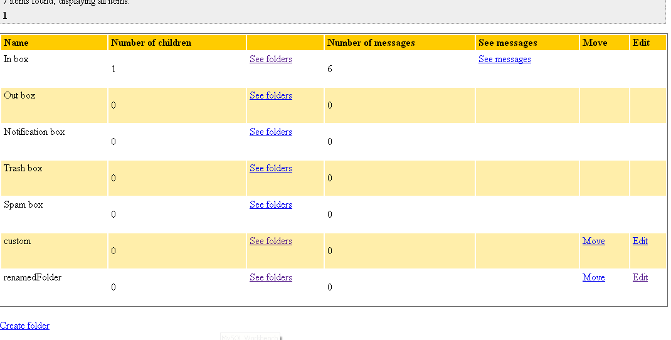

|  |  |
| --- | --- |
| **Test 001** | |
| **Description** | With the language set to “Spanish”, the testers must rename the folder ‘nuevaCarpeta’ to ‘carpetaRenombrada’. |
| **Expected** | The system must let them rename it. It appears in the list of folders with the new name. |
| **Outcome** |  |
| **Notes** |  |

|  |  |
| --- | --- |
| **Test 001** | |
| **Description** | With the language set to “English”, the testers must delete the folder ‘renamedFolder’ |
| **Expected** | The system must let them delete it. |
| **Outcome** |  |
| **Notes** |  |

|  |  |
| --- | --- |
| **Test 001** | |
| **Description** | With the language set to “Spanish”, the testers must delete the folder ‘carpetaRenombrada’. |
| **Expected** | The system must let them delete it. |
| **Outcome** |  |
| **Notes** |  |

|  |  |
| --- | --- |
| **Test 001** | |
| **Description** | With the language set to “English”, the testers must move the folder ‘custom’. It will be a child of ‘In box’. |
| **Expected** | The system must let them move it. The folder ‘custom’ will be in the list of ‘In box’ children folders. |
| **Outcome** |  |
| **Notes** |  |

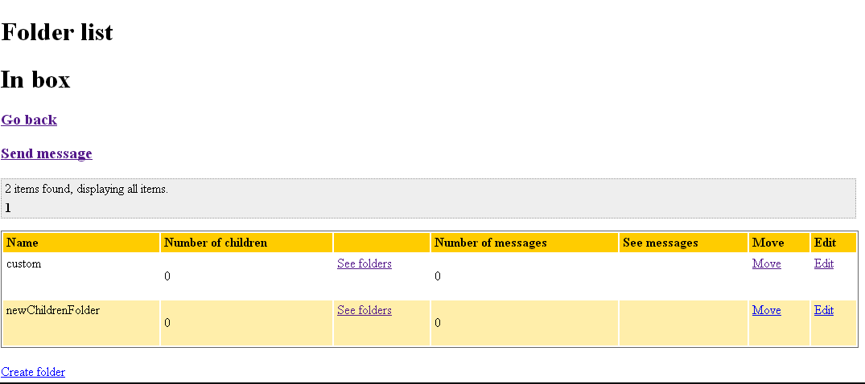

|  |  |
| --- | --- |
| **Test 001** | |
| **Description** | With the language set to “Spanish”, the testers must move the folder ‘custom’. It will be in the root. |
| **Expected** | The system must let them move it. The folder ‘custom’ will be in the list of folders. |
| **Outcome** |  |
| **Notes** |  |

# Use case 00: An actor who is authenticated as a user must be able to list the users who he or she follows.

Description

A user wishes to see the users he or she follows.

Access

(Logged as “user1”, please refer to the test related to logging as user for more information)

Main menu > User Actions > Following.

|  |  |
| --- | --- |
| **Test 001** | |
| **Description** | With the language set to “English”, the testers must list the user who he follows. |
| **Expected** | The system must let them list them. It will appear one user. |
| **Outcome** |  |
| **Notes** |  |

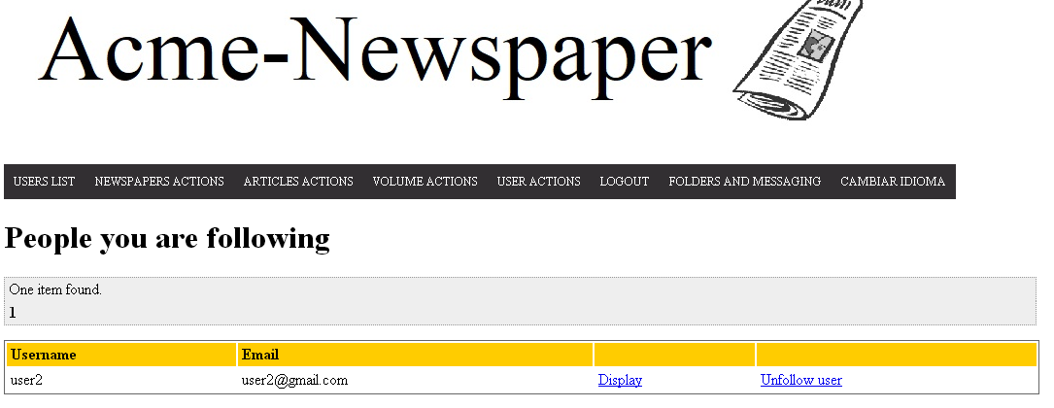

|  |  |
| --- | --- |
| **Test 001** | |
| **Description** | With the language set to “Spanish”, the testers must list the user who he follows. |
| **Expected** | The system must let them list them. It will appear one user. |
| **Outcome** |  |
| **Notes** |  |

# Use case 00: An actor who is authenticated as a user must be able to list the users who follow him or her.

Description

A user wishes to see the users follow him or her.

Access

(Logged as “user1”, please refer to the test related to logging as user for more information)

Main menu > User Actions > Follower.

|  |  |
| --- | --- |
| **Test 001** | |
| **Description** | With the language set to “English”, the testers must list the user who follow him. |
| **Expected** | The system must let them list them. It will appear two users. |
| **Outcome** |  |
| **Notes** |  |

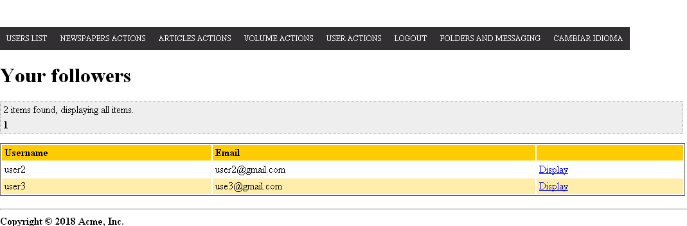

|  |  |
| --- | --- |
| **Test 001** | |
| **Description** | With the language set to “Spanish”, the testers must list the user who follow him. |
| **Expected** | The system must let them list them. It will appear two users. |
| **Outcome** |  |
| **Notes** |  |

# Use case 00: An actor who is authenticated as a user must be able to follow another user.

Description

A user wishes to see the users follow another user.

Access

(Logged as “user1”, please refer to the test related to logging as user for more information)

|  |  |
| --- | --- |
| **Test 001** | |
| **Description** | With the language set to “English”, the testers must go to the display of the user4 and follow him. |
| **Expected** | User1 now follows user4. If the testers click on the list of following users, now user4 will appear. If the testers log as user4 and list the followers, user1 must appear. |
| **Outcome** |  |
| **Notes** |  |

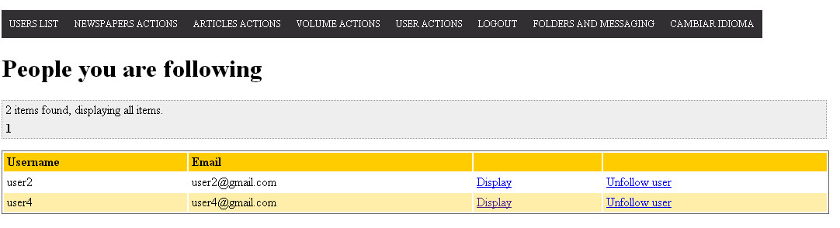

|  |  |
| --- | --- |
| **Test 001** | |
| **Description** | With the language set to “Spanish”, the testers must go to the display of the user3 and follow him. |
| **Expected** | User1 now follows user3. If the testers click on the list of following users, now user3 will appear. If the testers log as user3 and list the followers, user1 must appear. |
| **Outcome** |  |
| **Notes** |  |

# Use case 00: An actor who is authenticated as a user must be able to unfollow another user.

Description

A user wishes to unfollow another user.

Access

(Logged as “user1”, please refer to the test related to logging as user for more information)

Main Menu > User Actions > Following

|  |  |
| --- | --- |
| **Test 001** | |
| **Description** | With the language set to “English”, the testers must go to the list of following users and unfollow user4. |
| **Expected** | User1 is not following user4. If the testers click on the list of following users, now user4 will not appear. If the testers log as user4 and list the followers, user1 must not appear. |
| **Outcome** |  |
| **Notes** |  |

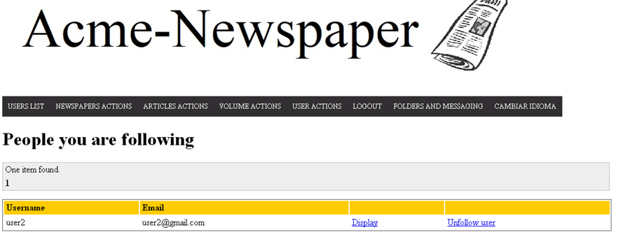

|  |  |
| --- | --- |
| **Test 001** | |
| **Description** | With the language set to “Spanish”, the testers must go to the list of following users and unfollow user3. |
| **Expected** | User1 is not following user3. If the testers click on the list of following users, now user3 will not appear. If the testers log as user3 and list the followers, user1 must not appear. |
| **Outcome** |  |
| **Notes** |  |

# Use case 00: An actor who is not authenticated must be able to register as a user.

Description

An actor who is not authenticated wishes to register as a user.

Access

Main Menu > Access to the system > Register as a user

|  |  |
| --- | --- |
| **Test 001** | |
| **Description** | With the language set to “English”, the testers must go to the form and click on ‘Save’ with all the inputs in blank. |
| **Expected** | The form will be opened again with messages in red, giving information about the blank inputs. |
| **Outcome** |  |
| **Notes** |  |

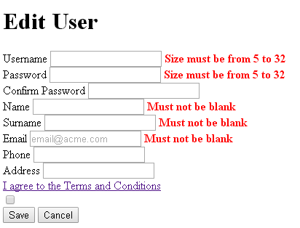

|  |  |
| --- | --- |
| **Test 001** | |
| **Description** | With the language set to “Spanish”, the testers must go to the form and click on ‘Enviar’ with all the inputs in blank. |
| **Expected** | The form will be opened again with messages in red, giving information about the blank inputs. |
| **Outcome** |  |
| **Notes** |  |

|  |  |
| --- | --- |
| **Test 001** | |
| **Description** | With the language set to “English”, the testers must go to the form and fill it, with all the data correctly written. Then, the testers will click on ‘Save’. |
| **Expected** | The main page will be opened. Then, if the testers try to log, the system let them. |
| **Outcome** |  |
| **Notes** |  |

|  |  |
| --- | --- |
| **Test 001** | |
| **Description** | With the language set to “Spanish”, the testers must go to the form and fill it, with all the data correctly written. Then, the testers will click on ‘Save’. |
| **Expected** | The main page will be opened. Then, if the testers try to log, the system let them. |
| **Outcome** |  |
| **Notes** |  |

|  |  |
| --- | --- |
| **Test 001** | |
| **Description** | With the language set to “English”, the testers must go to the form and fill it, with all the data correctly written, but the name will be <script>alert(‘Hacked’)</script>. Then, the testers will click on ‘Save’. |
| **Expected** | The form will be opened again. A message in red will inform about the unsecure data. |
| **Outcome** |  |
| **Notes** |  |

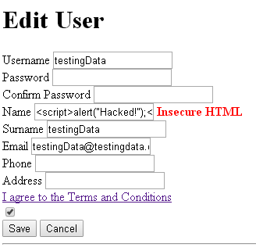

|  |  |
| --- | --- |
| **Test 001** | |
| **Description** | With the language set to “Spanish”, the testers must go to the form and fill it, with all the data correctly written, but the name will be <script>alert(‘Hacked’)</script>. Then, the testers will click on ‘Enviar’. |
| **Expected** | The form will be opened again. A message in red will inform about the unsecure data. |
| **Outcome** |  |
| **Notes** |  |